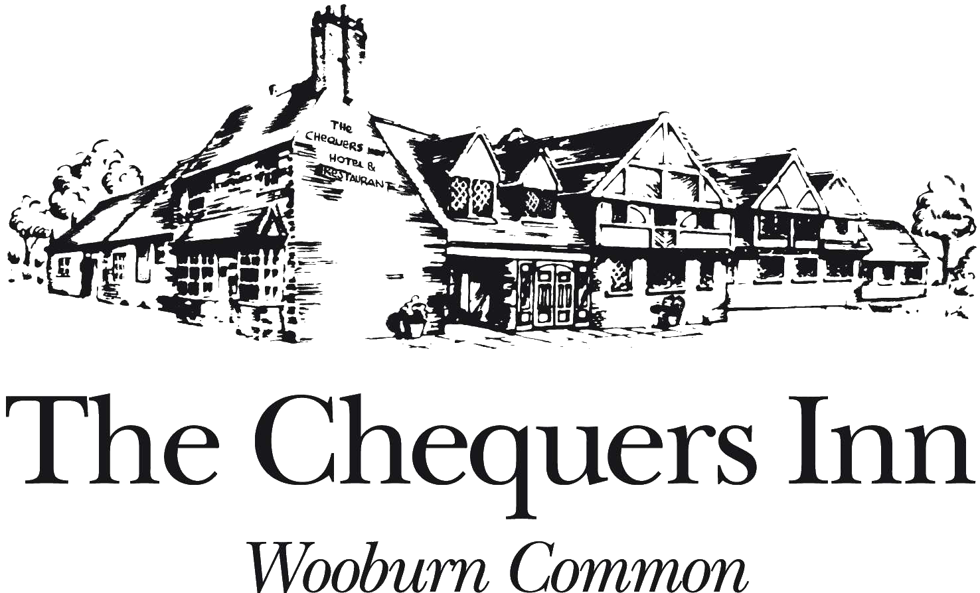

TO SHARE

Baked Camembert, Honey, Rosemary, Garlic, Toast | £12.95
Cerignola Olives | £4.95
Bread Basket, Balsamic, Olive Oil | £4.95
Smoked Onion Hummus, Hazelnut, Pitta Bread | £7.95

SMALL PLATES

Crispy Squid, Lemon Mayo | £9.50
BBQ Chicken Strips | £7.50
Mini Fish, Chips, Tartare Sauce | £9.50
Mini Cheeseburger, Chips | £8.95
Scotch Egg, Red Onion Marmalade | £8.50
Prawn Masala, Mango Chutney, Poppadum | £9.50
POULTRY AND GAME
Pan Roasted Chicken Supreme, Braised Red Cabbage & Apple | £21.95
Bubble & Squeak, Onion Jus  Loin of Venison, Truffle Rosti, Carrot Puree, Venison Jus | £24.95
 |  | 111
Chicken Curry, Rice, Onion Bhaji, Poppadum, Mango Chutney | £18.50
SALAD
 | 111
Chicken Caesar Salad, Anchovies, Parmesan, Croutons | £18.50
Honey Baked Goats Cheese, Heritage Beetroot, Pomegranate | £16.25
Balsamic Dressing
FISH
Fish of the Day | £ M/P
Pan Roasted Seabream, Sauté Potatoes, Peas a la Francaise | £22.95
Pave of Stone Bass, Braised Fennel, Hazelnut & Lemon Butter  Burnt Leeks, Creamed Potatoes | £23.95
Beer Battered Hake, Chips, Peas, Tartare Sauce | £18.50
Salmon, Cod and Prawn Fishcakes, Salad | £16.95
SAUCES
Shallot | £1.95
Pepper | £1.95
Stilton | £1.95

Fish Platter: | £17.00
Fried Squid, Scampi, King Prawn Skewer, Lemon Mayo
Meat Platter: Mixed Meats, Cheddar, Pickles, Bread | £19.50

STARTERS

Homemade Soup of the Day, Homemade Rolls |  | £9.50
Sticky Braised Beef Bon Bons, Horseradish Chantilly |  | £10.75
Charred Silver Skins
Spinach, Mushroom & Artichoke Tart, Pickled Mushrooms |  | £9.95
Chestnut Crumb, Parmesan & Chive Cream Sauce  Potted Mackerel Rillette, Pickled Carrot Salad, Sourdough |  | £12.95
Confit Duck Spring Roll, Pickled Asian Salad, Thai Dressing |  | £12.95
MEAT
Chargrilled Rump Steak £27.95 / Chargrilled Argentinian Sirloin |  | £33.95
Served with Mushroom, Tomato, Chips, Parmesan,
Onion Rings, Salad
Homemade Burger, Bacon, Cheese, Chips, Salad, Coleslaw |  | £18.95
Crispy Pork Belly, Honey Braised Chicory, Potato Croquette  Quince, Cider Sauce |  | £22.95
Cumberland Sausages, Mash, Onion Gravy |  | £17.95
Slow Braised Beef Short Rib, Parsley Pomme Puree  Wilted Greens, IPA Gravy |  | £23.95
VEGETARIAN/VEGAN
Wild Mushroom & Chestnut Risotto, Rocket  Crumbled Feta | £18.00
Goan Chickpea Curry, Cumin Rice, Cucumber Raita  Onion Bhaji, Poppadum | £17.50
SIDE ORDERS
Sweet Potato Fries |  | £5.25
Garlic Bread |  | £4.95
Mixed Salad |  | £4.95
Mixed Vegetables |  | £4.95
Onion Rings |  | £4.95

Some of our menu items contain allergens and there is a small risk that traces of these may be in any other dish or food served here. We understand the dangers to those with severe allergies, so have recorded which of our menu items contain any of the 14 named EU allergens as an ingredient. Please ask to speak to a member of staff for further information.
BY THE GLASS (vegan)

 |  | 175ML |  |  | 250ML | BOTTLE
 | WHITE
1. | Bella Modella, Pinot Grigio | Italy |  | £6.50 | £8.20 |  | £21.95
2. | One Chain, Chardonnay | Australia |  | £7.70 | £10.10 |  | £28.00
3. | Aromo, Sauvignon Blanc | Chile |  | £7.70 | £10.10 |  | £28.00
4. | False Bay, Chenin Blanc | South Africa |  | £7.35 | £9.40 |  | £26.00
5. | Aromo, Viognier | Chile |  | £7.70 | £10.10 |  | £28.00
6. | Artesa, Rioja Blanco | Spain |  | £8.80 | £11.40 |  | £31.00
7. | Mayfly, Sauvignon Blanc | New Zealand |  | £9.60 | £12.70 |  | £34.00
 | RED
8. | Sangiovese Puglia | Italy |  | £6.50 | £8.20 |  | £21.95
9. | Aromo, Merlot | Chile |  | £7.55 | £9.90 |  | £27.00
10. | Vega Piedra, Rioja Tinto | Spain |  | £7.70 | £10.10 |  | £28.00
11. | San Marzano, Primitivo ‘Il Pumo’ | Italy |  | £8.50 | £10.90 |  | £30.00
12. | Calusari, Pinot Noir | Romania |  | £7.70 | £10.10 |  | £28.00
13. | Aromo, Malbec | Chile |  | £8.80 | £11.40 |  | £31.00
 | ROSÉ
14. | Pinot Grigio Rosé, Casa Defra | Italy |  | £7.55 | £9.90 |  | £27.00
22. | Côtes de Provence Rosé I France |  | £10.95 | £13.95 |  | £37.50

CHAMPAGNE AND SPARKLING

15. | Etienne Oudart, Champagne | 125ML | £13.75 | £58.00
 | Hints of biscuit and along finish
16. | Veuve Clicquot |  |  | £85.00

Well balanced champagne with a biscuity taste and long finish

17. Bollinger | £90.00

A superior champagne which is always a favourite

18. Dom Perignon | £225.00

Top quality champagne from the ‘Father of Champagne’ (vegan)

19. | Casa Defra, Prosecco DOC Quarters | Italy | 200ML | £9.95
 | A fresh, fragrant, and fruity Prosecco with aromas of pear and apple |  | (vegan)
20. | Mirabello, Prosecco |  | £32.00
 | Lovely balance, crisp with elegant finish (vegan)
21. | Laurent-Perrier Rosé |  | £110.00
 | Classy French champagne for 200 years (vegan)

ROSE AND WHITE

 |  | BOTTLE
22. | Cotes de Provence Rosé I France | £37.50
 | Wonderful berry fruit on the nose with good minerality and
 | a well-structured finish (vegan)
23. | Mesta, Organic Verdejo | Spain | £30.00
 | Great purity with fresh notes of grass, fennel, and white pepper (vegan)
24. | Coral Do Mar, Albariño | Spain | £46.00
 | Founded by the Mendez Family, this wine is herbaceous and zesty (vegan)
25. | Ornezon, Picpoul de Pinet | France | £36.00
 | Citrus aromas and white fruits with a long finish (vegan)
26. | Domaine Seguinot, Chablis | France | £55.00
Wonderful richness on the palate, clean and fresh with an elegant
finish (vegan)
27. | Domaine Picard, Sancerre | France | £55.00
 | Aromatic notes of exotic fruit and citrus on the nose. On the palate the
 | wine is full bodied and balanced with a crisp finish (vegan)
28. | Yvon et Pascal Tabordet, Pouilly Fumé | France | £55.00
 | Floral and dried fruit scents with notes of kiwi,
 | melon and rhubarb. Dry and citrus zesty finish (vegan)
29. | Domaine les Vieux Murs, Pouilly Fuisse | France | £62.00
 | One of Burgundies finest white wines. Citrus fruit on the palate
 | with a complex nutty finish (vegan)

RED

31. | Mesta, Organic Tempranillo | Spain | £30.00
 | Vibrant and juicy, unoaked red wine (vegan)
32. | Château La Garenne, Bordeaux Rouge | France | £38.00
 | Dark berry fruit and earthy, tobacco aromas
33. | The Opportunist, Shiraz | Australia | £38.00
 | Lush, red, plump ripe fruit, creamy berry soaked, savoury finish (vegan)
34. | Domaine Fichet, Bourgogne Pinot Noir | France | £49.50
 | An easy drinking, light, soft and fruity wine (vegan)
35. | ‘Les Coteaux’, Côte du Rhône Villages | France | £36.00
 | Brambly fruit with subtle oaky nuances (vegan)
36. | Tumbleweed Winery, Founders Pinotage | South Africa | £35.00
 | Soft easy drinking wine with fresh black and red berries and a hint
 | of vanilla. Has well-rounded tannins on palate (vegan)
RED

37. | Bodegas Ondarre, Reserva Rioja | Spain | £39.00
 | Leather and spice of traditionally made Rioja on the nose (vegan)
38. Chianti Reserva | Italy |  | £44.00
 | Full of red cherry flavours and violets, with vibrant acidity,
 | hints of sweet spices and a beautiful long silky finish
39. | Château Treytins, Montagne-St-Emilion | France | £53.00
Full-bodied Claret with a wonderful deep colour. Pure fruit, silky and
very elegant (vegan)
40. | Châteauneuf du Pape, Les Cailloux | France | £97.00
 | Dark, warm red colour. Fruit driven with robust lingering flavours (vegan)

ENGLISH

42. | Oaked Aged Ortega, Dropmore Vineyard | England | £39.50
 | Delicate vanilla aromas with hints of butterscotch and honey (vegan)
43. | Bacchus, Dropmore Vineyard | England | £38.00
 | Young, fresh and zesty in style, it has a pleasing aromatic and grapey bouquet with a long fresh lemon grass and greengage finish (vegan)
44. | Pinot Blush, Dropmore Vineyard | England | £38.00
 | A dry, refreshing English rose with delicate flavours of raspberry and red cherry (vegan)
45. | Classic Cuvee Brut, Dropmore Vineyard | England | £47.00
 | An elegant blend of Pinot Noir, Pinot Meunier and Chardonnay, made in the traditional method (vegan)
46. | Sparkling Rosé Wine, Dropmore Vineyard | England | £75.00
 | Bright and delicate with gentle floral aromas and soft summer berry notes on a fine mousse with creamy texture on the finish (vegan)

DESSERT

 | GLASS | BOTTLE
Muscat Beaume de Venise 37.5CL | £6.60 | £36.00

PORT

 |  |  | 50ML | BOTTLE
 | Taylors Vintage Port 2017 |  | £4.85 | £45.00
Barros Tawny Port (10 Years Old) |  |  | £6.25 | £65.00
 | LIQUEUR AND BRANDY
Grand Marnier |  |  |  | £4.30
Disaronno |  |  |  | £4.10
Drambuie |  |  |  | £4.30
Galliano |  |  |  | £4.00
Kahlua |  |  |  | £3.90
Chartreuse |  |  |  | £4.60
Calvados |  |  |  | £4.95
Sambuca |  |  |  | £3.45
Grappa |  |  |  | £4.00
Limoncello Casal D’Emilia |  |  |  | £4.95
Baron de Sigognac |  |  |  | £6.55
Janneau Armagnac |  |  |  | £6.55
Remy Martin VSOP |  |  |  | £6.15
Remy Martin XO |  |  |  | £18.00
Hennessy XO |  |  |  | £18.00
 | FINE SCOTTISH MALT WHISKY
Talisker (10 Years Old) |  |  |  | £5.20
Soft, smoky nose and sweet taste, rich in barley malt
This is a robust taste to enjoy
Highland Park (12 Years Old) |  |  |  | £5.20
The nose is sweet with a peaky earthiness,
a heathery flavour and a huge smoky dryness
Chivas Regal (12 Years Old) |  |  |  | £4.10
Enjoy a distinctive blended honey & mellow
Taste for a refined smoothness.
Glenfiddich (12 Years Old) |  |  |  | £4.70
Fresh fruity aroma with a clash of pear, the taste is soft and rounded
Laphroaig (10 Years Old) |  |  |  | £6.80
Malted barley is dried over a peat fire
The smoke from the peat gives a rich flavour
Glenmorangie (10 Years Old) |  |  |  | £4.75
The fragrance is light, delicate and floral rather than cereal
The well-balanced flavour carries traces of honey wood and nuts
The Macallan (12 Years Old) |  |  |  | £9.00
This single malt is exclusively matured in selection of sherry oaks
 | WHISKEY
Jameson |  | £3.80 | Bushmills | £3.40
Red Label |  | £3.30 | Famous Grouse | £3.10
Bells |  | £3.10 | Canadian Club | £3.50

